## 8085 MICROPROCESSOR

## Introduction to 8085 Microprocessor

The 8085 is an 8-bit microprocessor developed by Intel in 1976. It uses NMOS technology and requires a single 5V power supply. The "85" in its name refers to the fact that it was designed to be binary compatible with the 8080, another Intel microprocessor, and has similar functionality with some enhancements.

## Architecture of 8085 Microprocessor

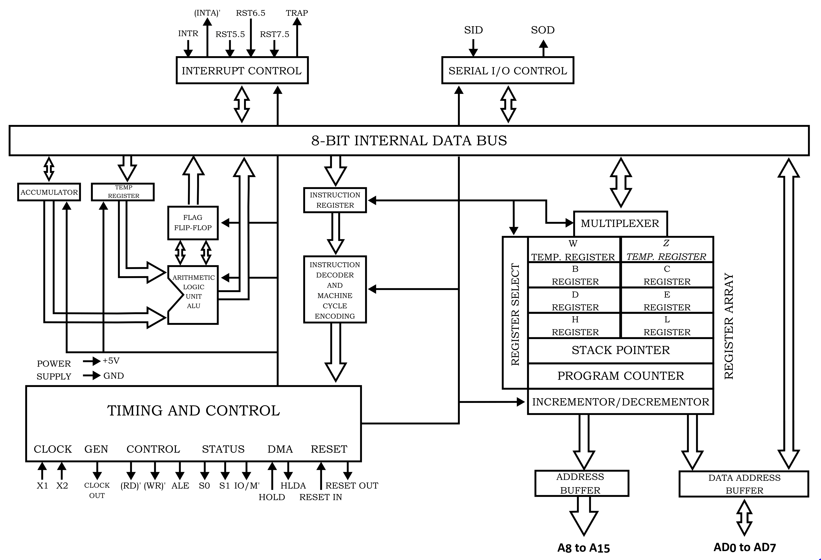

*Fig: 8085 Microprocessor Architecture*

The 8085 architecture includes the following components:

* Arithmetic and Logic Unit (ALU): Performs arithmetic operations (addition, subtraction) and logical operations (AND, OR, NOT).
* Registers: Includes the Accumulator, temporary registers, general-purpose registers (B, C, D, E, H, L), special-purpose registers (Program Counter, Stack Pointer).
* Interrupt Control: Manages interrupt signals.
* Serial I/O Control: Manages serial data communication.
* Timing and Control Unit: Generates timing and control signals to synchronize operations.

## Pin Configuration

## 8085-Pin-Diagram-and-Functional-Pin-Diagram-of-8085-Microprocessor-001

The 8085 microprocessor has a 40-pin dual in-line package (DIP). Key pins include:

* VCC: +5V power supply.
* GND: Ground.
* X1, X2: Clock input pins.
* RESET IN: Resets the microprocessor.
* READY: Indicates if the peripheral is ready for data transfer.
* HOLD: Requests the microprocessor to relinquish control of the bus.
* HLDA (Hold Acknowledge): Indicates that the microprocessor has relinquished control of the bus.
* INTR (Interrupt Request): General-purpose interrupt.
* INTA (Interrupt Acknowledge): Acknowledges interrupt requests.
* RST5.5, RST6.5, RST7.5, TRAP: Interrupt pins.

## Registers

Registers are small storage locations within the CPU that hold data temporarily:

* Accumulator (A): An 8-bit register used for arithmetic and logic operations.
* Temporary Register: Used internally by the ALU for intermediate calculations.
* General-Purpose Registers: B, C, D, E, H, and L can be used individually as 8-bit registers or in pairs (BC, DE, HL) for 16-bit operations.
* Program Counter (PC): A 16-bit register that holds the address of the next instruction to be executed.
* Stack Pointer (SP): A 16-bit register that points to the top of the stack in memory.

## Flag Register

## IMG_256

The flag register holds status flags that indicate the outcome of operations:

* Sign Flag (S): Set if the result is negative.
* Zero Flag (Z): Set if the result is zero.
* Auxiliary Carry Flag (AC): Set if there is a carry from the lower nibble.
* Parity Flag (P): Set if the number of set bits is even.

Carry Flag (CY): Set if there is a carry out of the most significant bit.

## Instruction Set

The 8085 microprocessor has 74 instructions classified into five categories:

* Data Transfer Instructions: Move data between registers, memory, and I/O ports (e.g., MOV, MVI, LDA, STA).
* Arithmetic Instructions: Perform arithmetic operations like addition, subtraction, increment, and decrement (e.g., ADD, SUB, INR, DCR).
* Logical Instructions: Perform logical operations like AND, OR, XOR, and compare (e.g., ANA, ORA, XRA, CMP).
* Branch Instructions: Change the sequence of execution based on conditions (e.g., JMP, CALL, RET, JZ, JNZ).
* Control Instructions: Control machine operations (e.g., NOP, HLT, DI, EI).

## Addressing Modes

Addressing modes determine how the operand of an instruction is selected:

* Immediate Addressing: Operand is specified in the instruction itself (e.g., MVI A, 25H).
* Direct Addressing: Address of the operand is given in the instruction (e.g., LDA 2050H).
* Register Addressing: Operand is in a register (e.g., MOV A, B).
* Register Indirect Addressing: Address of the operand is in a register pair (e.g., MOV A, M, where M is the memory location pointed to by HL).
* Implicit Addressing: Operand is implied by the instruction (e.g., CMA).

## Interrupts

Interrupts are signals that divert the processor to execute a particular routine:

* TRAP: Non-maskable, highest priority interrupt.
* RST7.5, RST6.5, RST5.5: Maskable, vectored interrupts.
* INTR: General-purpose, maskable interrupt.
* INTA: Interrupt Acknowledge signal.

## Timing and Control Signals

The 8085 microprocessor uses various signals to control operations:

1. Control Signals:

* RD (Read): Indicates read operation.
* WR (Write): Indicates write operation.
* ALE (Address Latch Enable): Indicates that the lower byte of the address bus is valid.
* IO/M: Distinguishes between I/O and memory operations.

1. Status Signals:

* S0, S1: Indicate the type of machine cycle.

1. Timing Signals:

* CLK (Clock): Provides the necessary timing for operations.

## Machine Cycles and Timing Diagrams

Machine cycles are the basic operations the microprocessor performs to execute instructions:

* Opcode Fetch: Fetches the opcode from memory.
* Memory Read: Reads data from memory.
* Memory Write: Writes data to memory.
* I/O Read: Reads data from an I/O port.
* I/O Write: Writes data to an I/O port. Timing diagrams show the relationship between control signals and the system clock during these cycles.

## Instruction Cycle

The sequence of operations the microprocessor performs to execute an instruction:

* Fetch: The instruction is fetched from memory.
* Decode: The instruction is decoded to determine the operation.
* Execute: The operation is performed.

## Bus Organization

The microprocessor communicates with memory and I/O devices using buses:

* Address Bus: 16-bit bus used to address memory locations.
* Data Bus: 8-bit bus used to transfer data.
* Control Bus: Carries control signals like RD, WR, IO/M, etc.

## Serial Communication

The 8085 microprocessor supports serial communication:

* SID (Serial Input Data): Receives serial data.
* SOD (Serial Output Data): Sends serial data.
* Serial communication protocols: Defines rules for serial data exchange.

## Applications of 8085

The 8085 microprocessor is used in various applications:

* Basic Computing Devices: Early computers and calculators.
* Embedded Systems: Control systems in appliances, automobiles, and other devices.
* Educational Purposes: Teaching microprocessor fundamentals and programming.